 

WIU Chapter - SUAA

Newsletter

Serving the interest of the annuitants and survivors of Western Illinois University

**Fall 2015**

|  |  |
| --- | --- |
| **OFFICERS AND EXECUTIVE BOARD**  **2015- 2016**  **President**  Jackie Thompson  **President-Elect**  Patti Jones  **Past President**  Marcia Lucas  **Secretary**  Jacqlin Richmond  **Treasurer**  Penelope Yunker    **Directors**  Candace McLaughlin  Deckle McLean  Sandra Nelson  **Foundation Chair**  Michael Pledge  **Legislative Chairs**  Nick Pano  Charles Gilbert    **Newsletter Editor**  Gil Belles  **Webmaster**  Dennis Werling  **Membership Chairs** Judy Brown  Karen Helmers  **Survivor Assistance Chairs**  Fran Hedblade  John Maguire  **Social Chair**  Charlene Callison  **SUAAction Representative**  Nick Pano  **WIU Human Resources Representative**  Bill Rupert    **Springfield Liaison**  Maurine Magliocco | SUAA FALL LUNCHEON  TUESDAY, OCTOBER 20, 2015  SOCIAL PERIOD 11:30  LUNCH AT NOON  WESLEY UNITED METHODIST CHURCH  1212 W CALHOUN STREET  MACOMB  MENU  Hot chicken salad Green beans almandine Cranberry gelatin salad Rolls and butter Iced tea and coffee Apple Crisp with whipped cream   Vegetarian Choice  Spinach quiche Green beans almandine Cranberry gelatin salad Rolls and butter Iced tea and coffee Apple Crisp with whipped cream  $14.00 per person  The reservations should be sent to Penny Yunker and that form should include the name(s) of the person sending in the reservation and check.    SUAA FALL LUNCHEON RESERVATION FORM  RSVP BY THURSDAY! OCTOBER 15, 2015  I/we plan to attend the Fall Luncheon on Tuesday, October 20 at noon.  Name(s):  Number Attending:  Main Course Selection (Indicate number):  ______ Hot Chicken Salad _______ Spinach Quiche  For reservations, please make checks payable to WIU-SUAA. Remit $14 per person to:  Penny Yunker, Treasurer  1901 Riverview Drive  Macomb, IL 61455 |

**MESSAGE FROM THE PRESIDENT:**

Jackie Thompson

I hope everyone had a great summer. SUAA has been active this summer monitoring the State of Illinois budget deliberations as well as any pension issues that might have an impact on retirees. We are especially pleased that the premiums collected from retirees for their health insurance were refunded as a result of a ruling from the Illinois Supreme Court.

The WIU SUAA chapter will continue to monitor and react to the State of Illinois budget deliberations and the impact the decisions made will have on retirees and Western Illinois University. Needless to say, it is very difficult for WIU to operate without a budget.

If you are not a member of SUAA, please consider joining. In addition to our monthly WIU SUAA board of directors meetings, there is a fall luncheon, winter snow bunny luncheon and spring annual dinner. At each of these events, updates are given that are pertinent to retirees and WIU employees. Attendees also have the opportunity to socialize and ask questions before and during these meetings. Please visit the SUAA website on the WIU website that provides updates and information of interest to retirees.

I hope to see you at our fall luncheon. Marian Swisher, Charlene Callison and the Methodist Church women always provide a wonderful meal.

**LEGISLATIVE UPDATE:**

Nick Pano

There are currently three ongoing developments that could have significant implications for SUAA members and Illinois public higher education. These include: the current impasse on the FY 16 budget between Governor Rauner and the leadership of the Democratic-controlled Illinois General Assembly, the stalemated compensation and benefits contract negotiations between AFSCME and the State of Illinois, and the potential appeal by Attorney General Lisa Madigan to the U. S. Supreme Court of the May 2015 Illinois Supreme Court decision that declared the so-called state pension reform law unconstitutional.

Although Governor Rauner has acknowledged the need for additional revenue to balance his proposed FY 16 budget, he has threatened to veto any bills increasing taxes until the General Assembly approves some of the key aspects of his Turnaround Illinois Agenda, especially those which would diminish public employee collective bargaining rights, temporarily freeze local property taxes, and revise workman’s compensation laws. The Democratic legislative leadership, however, has rejected the governor’s proposals and has insisted that taxes be raised to cover the projected budgetary deficit.

It is now unclear how and when this stalemate will end. But should the crisis not be resolved in the next month or two, it is likely that the state will experience some serious cash-flow problems by year’s end. This reality should serve as a prod to both parties to address the budget issue.

Similarly, negotiations between AFSCME and the State of Illinois remain deadlocked. At the behest of Governor Rauner, the state’s negotiating team has sought to weaken the role and scope of collective bargaining for public sector employees and to impose a wage freeze of up to four years for state employees. By court order, state employees continue to be paid at their current salary levels while negotiations continue.

With the concurrence of Governor Rauner, Attorney General Lisa Madigan has been exploring the advisability of appealing to the U. S. Supreme Court the decision in the pension reform case. The deadline for filing this request is September 10.

**BENEFITS OFFICE:**

Bill Rupert

**United Healthcare Medicare Advantage Plan**

If you are a United Healthcare member, you may be getting a call asking if a doctor can come into your home. All of the Medicare Advantage plans have extra benefits that are in place to assist those in United Healthcare in staying healthy. If you do receive a call and would like to take part in this free service, just make sure that the doctor shows you his/her credentials when entering your home. This is not a mandatory service. You are under no obligation to accept this service if you do not want it. You should contact SURS, [800-275-7877](callto:800-275-7877) or CMS, [800-442-1300](callto:800-442-1300) if you have questions.

**FLU SHOT CLINIC FALL 2015**

The flu shot clinic will be held on Wednesday, October 14, 2015 from 8:30am - 4:00pm in the University Union Heritage Room. Shots are available to all WIU employees/retirees and other state agency employees. Please have your state health ID card available at the door. Dependents and spouses are not eligible.

**MEMBERSHIP CO-CHAIRS :**

Judy Brown and Karen Helmers

We have a new membership co-chair, Judy Brown, who has joined our executive board for our WIU SUAA Chapter. We welcome Judy to our executive board and know she will do a great job recruiting new members and working with all current members.

As your membership co-chairs, you will see us busily recruiting at numerous events throughout the year. We will set up a table to recruit new member at the Flu Shot Clinic held on the WIU campus this fall. We will also have brochures and information at all of our local SUAA events. Please stop by our table and ask any questions you may have or pick up an application. Remember: SUAA is an organization for both retirees and for current

employees. If you are not a SUAA member, why should you join? The answer is simple — SUAA is at the forefront working with our legislators to protect any deeper reforms to the public pension systems and the healthcare benefit systems. It is imperative now for public university employees, both past and present, to band together to preserve our pensions and our healthcare benefits.

To join, log on to [www.suaa.org](http://www.suaa.org) or fill out the Membership Application in this newsletter with either a check for $42.00 or the Dues Deduction Authorization Form to:

SUAA

217 E. Monroe Suite 100

Springfield, IL 62701

If you have any questions please contact either:

Karen Helmers at 1003 Bayberry Lane, Macomb, IL 61455 or 309 833-4812

Judy Brown at 502 East Wood Street; Avon, IL 61415 or 309 255-6716

**SUAA MEMBERSHIP APPLICATION**

Select the option best for you:

1. _____ Automatic Dues Deduction ($3.50 deducted from your monthly check)

2. _____ Single Payment ($42 annual payment) Make check payable to SUAA

You are:

An _____ Employee _____ A Retiree _____ A Spouse _____ A Spouse and Retiree _____ A Surviving Spouse

Name Spouse

Address City State Zip

Telephone Email

Required for Automatic Dues Deduction: Social Security # (last four digits only)________ I hereby authorize the State Universities Retirement System (SURS) or WIU Payroll to deduct each month the amount certified by the WIU/SUAA Chapter as current rate of dues. The deduction is to start on the first day of _________________(month). I also authorize SURS to provide change of address information to the Chapter.

**Mail signed form to SUAA**

Signature required Date  **217 E. Monroe Suite 100**

**Springfield, Illinois 62701**

**SUAA PRESENCE AT GOLF OUTING**

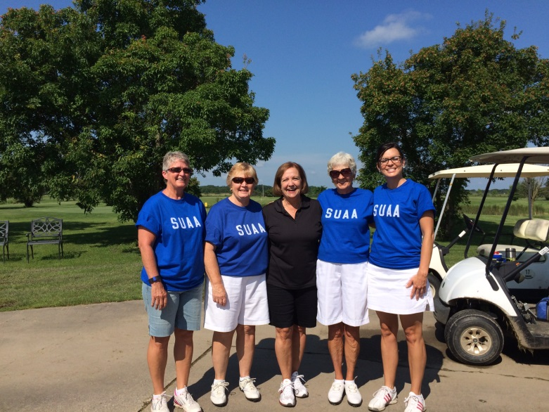 On July 10, 2015 the Western Illinois University SUAA Chapter was represented at the annual Norine Hammond golf outing. The event was held at Gold Hills Golf Course in Macomb, IL.  Team members wore SUAA t-shirts to let other golfers know who we were.  It was an opportunity to express appreciation for how protecting our pensions and saving our healthcare benefits had been addressed, and have a good time while doing it.  Our current WIU Chapter president, Jackie Thompson, worked as a volunteer for the day assisting Norine and her staff wherever help was needed.  It was an opportunity to be on a "par" with a SUAA supporter at the legislative level.  A BIG thank you to our local SUAA members who donated money and prizes.  See the photo in this newsletter.

left to right: Connie Garner, Karen Helmers, Norine Hammond, Sandra Sullivan, and Jami Minter



Human Resources

State University Annuitants Association Foundation Inc.

1 University Circle

Macomb, IL 61455-1390