ON-LINE TIME CARDS
Bi-Weekly Employees
TIME screens have been implemented to allow employees to enter their time on-line, rather than using paper timecards.
Employees will be able to enter their hours beginning the first day of the work period through the first day of the next work period, usually ending at 10:00 a.m. on that day.
The TIME screens are available through WIUP on the Web or through WIUP on the MVS system. Following are the instructions to access the TIME screen through WIUP on the Web.
To access the screens online, go to http://mvs.wiu.edu/ and click on WIUP in the upper right hand corner of the screen.
The Access Agreement will then be displayed.
Click on “Yes, I agree” and the WIUP Production Sign-on screen will be displayed.
The user should sign in with their userid and password, then click on “sign-on” or press enter.
The NEWS screen will then be displayed. Important messages will be displayed here.
The user can then click on the “TIME: Time Reporting” tab or type TIME in the “Display” field and press enter.
The Employee Time Reporting - Selection screen will appear with employee’s name.
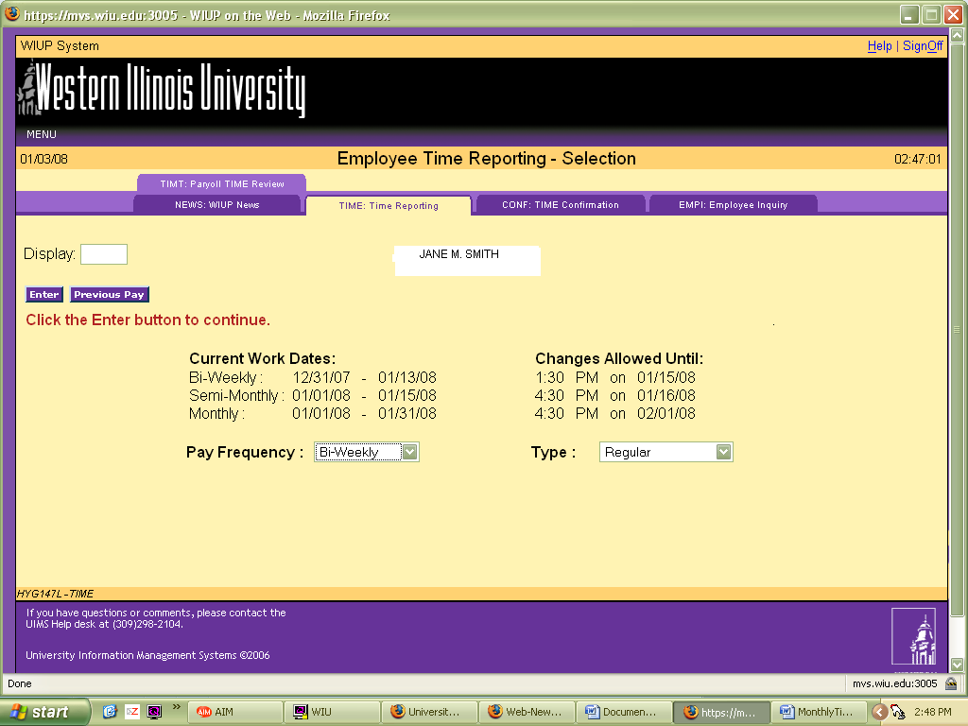
The current timecard work dates will be displayed on the screen. Pay Frequency will default to 1 for Bi-weekly employees. Type will default to Regular for Regular hours, but this can be changed to Other Dept Charge for departmental charges to other accounts.
For Regular Hours click on the enter button.
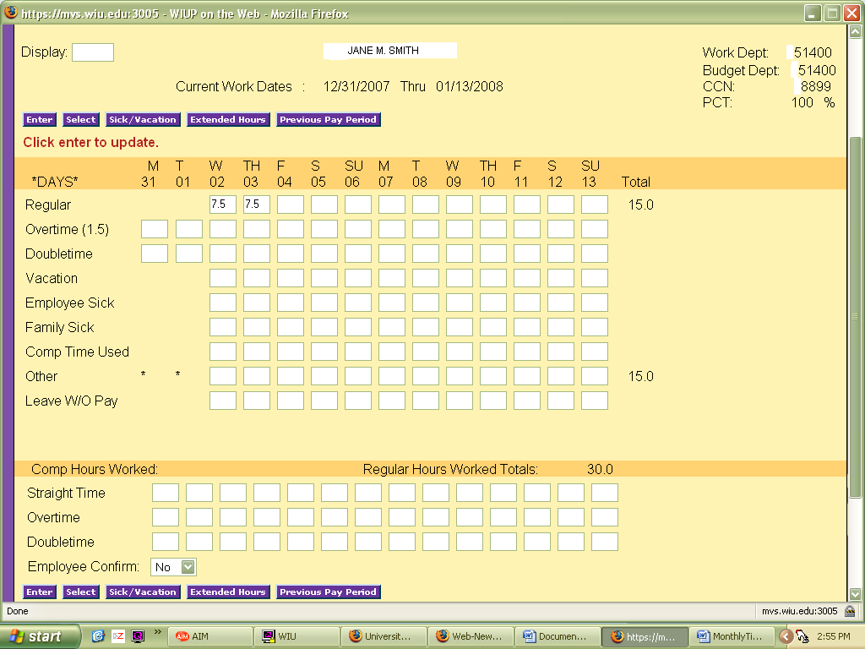
The Bi-weekly Time Reporting screen will display. This screens lists the dates covered during the current work period. For Bi-weekly employees the time worked is entered to the nearest tenth of an hour. If the hours do not calculate correctly, an error message " Daily Tot Hrs Not Correct HOURS EXCEED 37.5/40 and the incorrect hours will be marked with an asterisk.
If the employee is entitled to night shift and/or moving hours, those fields will be displayed on the screen.
If sick, vacation and/or compensation hours are reported there are edit checks in place so that the time used does not exceed the time earned.
Compensation hours earned should be reported as straight time, overtime or doubletime under Comp Hours Worked.
If there are any holidays during the pay period they will be noted with an asterisk (*). Administrative closure days are noted with a plus (+).
If time is entered in "Other Hours" the employee is required to enter a reason code. Press the Other button to go to the Bi-weekly - Reason Code/Des Update screen.
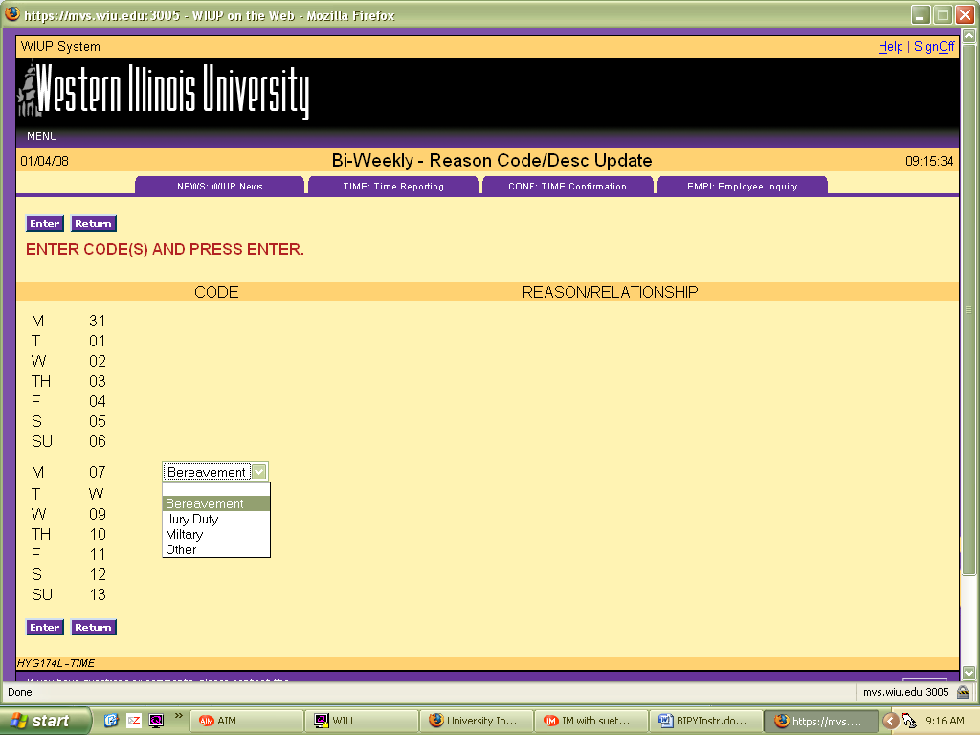
The reason codes are in a drop down box next to the date the Other Hours were entered. Choose either Bereavement , Jury Duty, Military or Other. If Bereavement is chosen, another drop down box will be displayed so the relationship of the person the bereavement leave is being used for can be entered. For Military leave, be sure to send a copy of the Military orders to the Human Resources office. For Other leave, click on Other in the drop down box. A blank box will be displayed to enter Extended Paid Medical leave.
After the screen is completed, click on the Return button to return to the Bi-weekly Time Reporting screen.
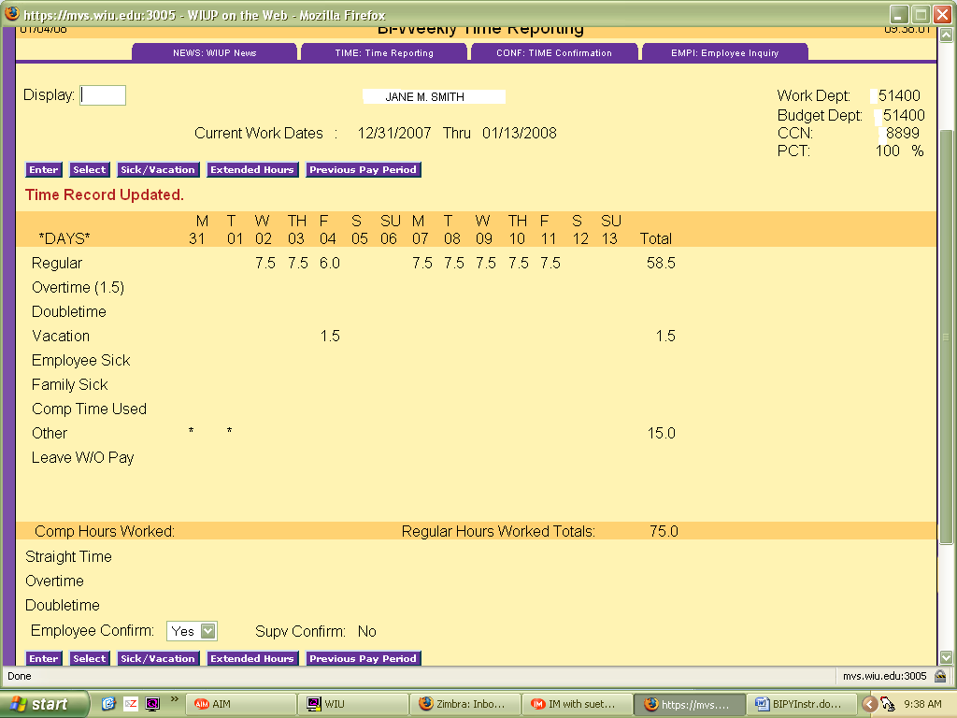
After all the hours have been entered, click on the drop down box next to Employee Confirm and click on Yes. If the hours were entered correctly, the message "Time Record Updated" will be displayed and the Supv Confirm will be displayed.
For employees with two or more contracts, it is necessary to click on the Next Contract button to see the next contract. To return to the previous contract click on the Previous Contract button.
To report Other Department Charges, click on the Select button. The Employee Time Reporting - Selection screen will be displayed. Click on the drop down box next to Type and click on Other Department Charge.
Enter the charge department and then enter the overtime or doubletime hours worked. Night shift hours will need to be entered on this screen also.
A reminder email will be sent to the employee and the employee's supervisor the day before a timecard is due. If the timecard has not been confirmed by the due date, a second reminder notice will be sent to the employee and the employee's supervisor. If an employee is going to be gone when the timecard is due, the employee can confirm the timecard early.
If an employee has not confirmed the timecard and is out of the office the day the timecard is due, Payroll is able to confirm the timecard with a P in the employee confirm space. Payroll can also enter any hours that have not been entered by the employee. If the supervisor has not confirmed the timecard and is out of the office the day timecards are due, there are two options. First, if there is another designated supervisor in the office, that person can confirm the timecard. Second, Payroll can put a P in the supervisor confirm space. If Payroll confirms the timecard, an email will be sent to the employee or supervisor, asking that person to confirm the hours entered. If there are no changes, the employee can simply reply to the email stating that there are no changes. If there are adjustments to be made, the employee's supervisor must send an email or memo to Payroll requesting a change.
Accumulated Sick and Vacation hours can be seen by clicking on the Sick/Vacation button. Click on the Return button to go back to the TIME screen after viewing the sick and vacation balances.
Any questions regarding the use of this system may be directed to Vicky Woolam in the Payroll Office at 298-1867 or Lisa Hinman in the Business Office at 298-1811.
1/4/08

